Cau 1:
- Use case diagram
Use case add new dish
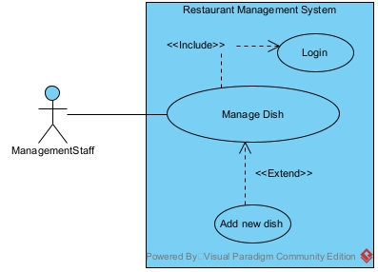
Login: this use case enable the management staff to log into the system
Manage dish: this use case enable the management staff to manage dish information, such as edit dish, add dish or delete dish
Add new dish: this use case enable the management staff to add a new dish to the database

Use case book table online
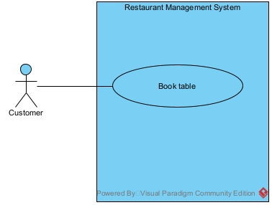
Book table: this use case let the customer enter date and time, choose a table, enter personal information and book a table online
- Scenario
Use case add new dish
Use case | Add new dish
Actor | Management staff
Pre-condition | Management staff has an account
Post-condition | A new dish is added to the database
Main events | - The management staff open the system  - The system display a login interface with a text box for username, a password field for password and a login button  - The management staff enter username, password and click login  - The system display the staff main menu, with at least a button for manage dish information  - The management staff click manage dish information button  - The system display the manage dish information interface, with at least a button to add new dish  - The management staff click add new dish button  - The system display the add new dish interface, with text box for name, price and description  - The management staff enter the dish information such as name, price and description, and click save  - The system display a success message
Exception | 4. The system display login error message  4.1 The management staff click ok  4.2 The management staff re-enter the username and password correctly and click login  4.3 The system display the interface in step 4

Use case book table online
Use case | Book table online
Actor | Customer
Pre-condition
Post-condition | A new booking is saved in the database
Main events | - The customer open the system  - The system display the customer main menu, with at least a button for book table online  - The customer click book table online button  - The system display the book table online interface, with a field to enter date and a field to enter time, and a search button, and an empty list  - The customer enter date and time and click search  - The system display avaible table for the selected date and time in the list  - The customer click on a table they want to book  - The system display a confirm message, include date, time, and table, with text field for customer name, phone number  - The customer enter name, phone number and click confirm  - The system display a success message
Exception | 6. The system display empty list  6.1 The customer choose a different date and/or time and click search again  6.2 The system display the interface in step 4

Question 2:
- Extract entity class
Step 1: Describe the system in a paragraph
The system is a restaurant management system that enables many user such as management staff, sale staff and customers to use different functions. Management staff can view statistics of dishes, ingredients, customers and suppliers. They can also manage dish and menu item information, make combo menus. Warehouse staff can make import invoice with materials from suppliers, manage supplier information. Sale staff can receive customers, take orders, receive payments at the table and make invoice, make membership cards for customers, confirm table reservation information and order online. Customer can search, book a table and order food online.
Step 2: Extract noun:
- Related to people: user, management staff, sale staff, warehosue staff, customer
- Related to thing: dish, ingredient, combo, menu item, table, membership card, reservation, order, invoice
- Related to system: statistics
Step 3: Evaluate noun:
- User: make a class User: name, username, password, phone, email
- Management staff: make a class ManagementStaff
- Sale staff: make a class SaleStaff
- Warehouse staff: make a class WarehouseStaff
- Customer: make a class Customer
- Dish: make a class Dish:
- Ingredient: make a class Ingredient: name, description
- Combo: make a class Combo:
- Menu item: make a class MenuItem: name, price, description
- Table: make a class Table: name, condition
- Membership card: make a class MembershipCard: point, dateCreate, dateExpire
- Reservation: make a class Reservation: time, date, status
- Order: make a class Order: total
- Invoice: make a class Invoice: total, date and ImportInvoice: date
- Statistics: create class CustomerStatistics: revenue and DishStatistics: revenue and SupplierStatisitics
Step 4: Determined quantity relationship between entity:
- 1 Supplier has many ImportInvoice, 1 Import Invoice belong to 1 Supplier -> 1-n relationship
- 1 WarehouseStaff has many ImportInvoice, 1 Import Invoice belong to 1 WarehouseStaff -> 1-n relationship
- 1 SaleStaff manage many Invoice, 1 Invoice manage by 1 SaleStaff -> 1-n relationship
- 1 Reservation has 1 1 Invoice, 1 Invoice belong to 1 Reservation -> 1-1 relationship
- 1 Customer can have many Reservation, 1 Reservation belong to only 1 Customer -> 1-n relationship
- 1 Reservation has 1 Table, 1 Table belong in many Reservation -> 1-n relationship
- 1 Ingredient can be in many import Invoice, 1 ImportInvoice can have many Ingredient -> n-n relationship
- 1 Reservation can have many MenuItem, 1 MenuItem can be in many Reservation -> n-n relationship
- 1 Dish can be in many Combo, 1 Combo has many Dish -> n-n relationship
Step 5: Determined object relationship between entity:
- Inherit(“is a” relationship):
  - A SaleStaff, ManagementStaff, WarehosueStaff, Customer is a User
  - A Dish and a Combo is a MenuItem
  - CustomerStatistics
- Aggregation(“has a” relationship):
  - A ImportInvoice has a Supplier and a Management staff
  - A Reservation has a Customer
  - A Invoice has a Reservation
  - A Invoice has a SaleStaff
  - A reservation has a Table
- Association
  - ImportInvoice associate with Ingredient to create ImportIngedient: quantity, price
  - Dish associate with combo to create DishCombo: quantity
  - Reservation associate with MenuItem to create ReservationOrder: quantity, price
- Build entity class diagram

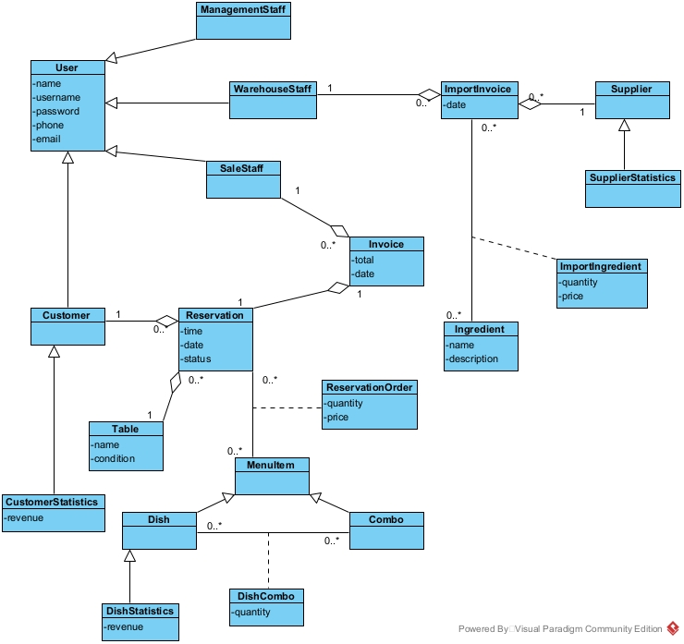
Question 5:
- Package diagram
The system package are designed as follow:
- All model class are place in the Model package
- All dao class are place in the DAO package
- All controller class are place in the Controller package
- All jsp class are place in the View package. The View pakckage is further divided as follow:
  - All jsp class related to the customer are place in the Customer subpackage
  - All jsp class related to the staff are placed in the Staff subpackage
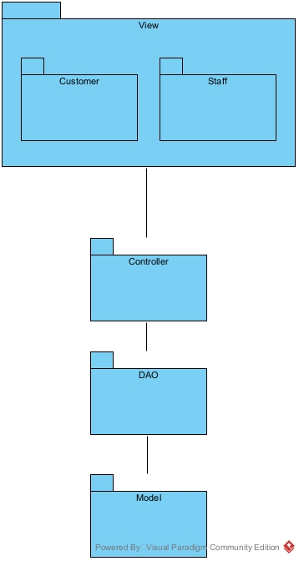
- Deployment diagram
The system deployment is design as follow:
- Client node: Many client send request from Web browser(Google Chrome 80+, Microsoft Edge 78+, Mozilla Firefox 80+)
- Server node: 1 Server handle client request and queries to the database(JDK 23, Apache Tomcat 10.1.24, MySQL Connector 8.4.0, JDBC 12.6.1)
- Database: 1 Database store all data and queries(SQL Server 16.0.1160.1)
- Connection:
  - Client <-> Server: HTTP
  - Server <-> Database: JDBC
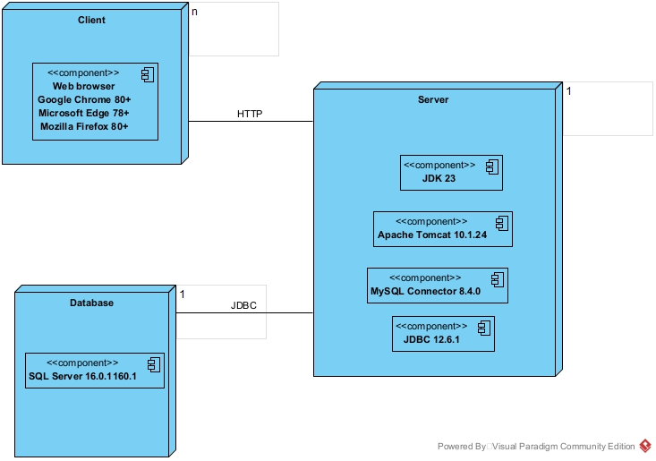
Question 3:
- Communication diagram
Use case add new dish
Use ca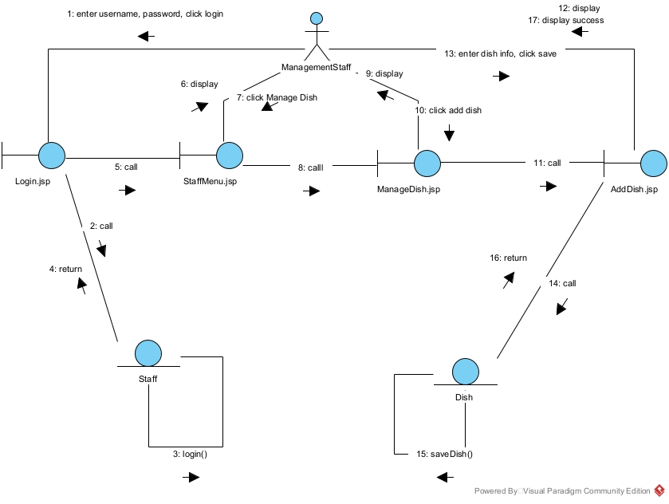
Use case book table online
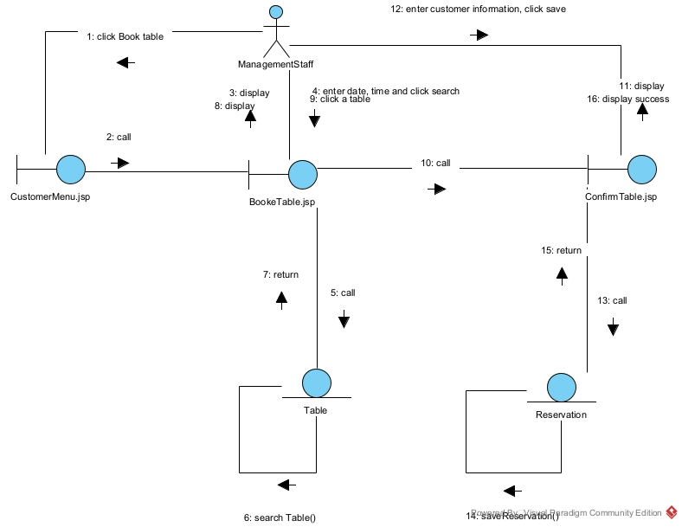
Question 4:
- Database
